**Transfer Wi-Fi credentials over BLE and connect to Wi-Fi using ESP32 Devkit V1**

**By Nirvan Tamhane**

**Table of Contents**

1. **Task Details**
2. **Hardware Components Used**
3. **Tools Used**
4. **Microcontroller Interfacing**
5. **Firmware**
6. **Issues Faced and Resolution**
7. **Outputs**
8. **nRF Connect Application Interface**
9. **References**

**Task Details**

Transfer Wi-Fi credentials over Bluetooth and connect to Wi-Fi using a smartphone to send the credentials.

**Hardware Components Used**

1. Espressif System's ESP32 Devkit V1 Development Board
2. USB to MicroUSB Cable
3. Breadboard

**Tools Used**

**Arduino IDE**

Arduino Integrated Development Environment or Arduino Software (IDE) contains a text editor for writing code, a message area, a text console, a toolbar with buttons for common functions, and a series of menus. It connects to the Arduino hardware to upload programs and communicate with them.

* For more details, refer to: [Arduino IDE](https://www.arduino.cc/en/software)

**Microcontroller Interfacing**

* **BLE Protocol: Used for connectivity with the nRF Connect Mobile Application.**
* **Wi-Fi Protocol: Used to connect the microcontroller to the WLAN network.**

**Firmware**

**Link:** [**Firmware .ino File**](https://github.com/Nirvan007/ESP32_WIFI_CREDS_OVER_BLE/blob/main/Firmware/Nineti_Assignment_BLE_WiFi_Creds/Nineti_Assignment_BLE_WiFi_Creds.ino)

**Issues Faced and Resolution**

**Space Problem in the ESP32 Devkit V1 Board**

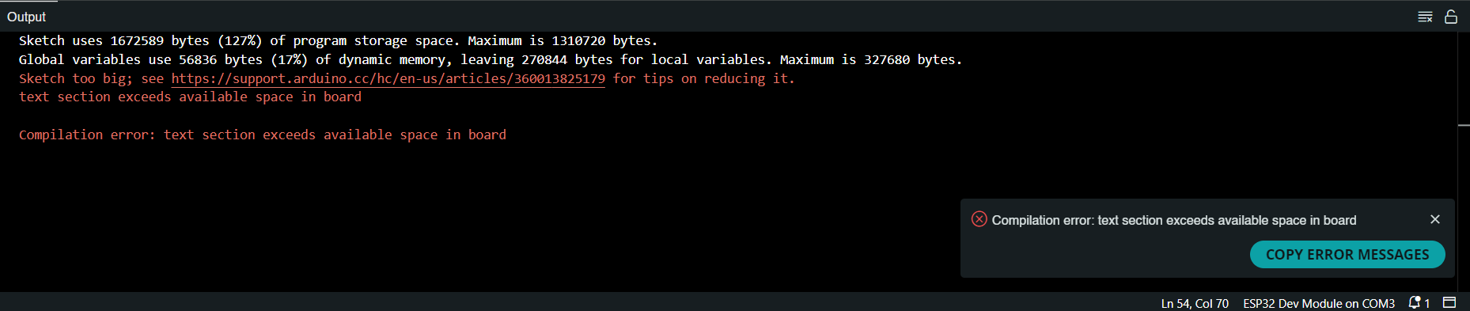

**Approach 1:**

* **Changed the board type to ESP32 Dev Module (as both could be used for uploading the code, i.e., they have the same ESP32-WROOM chip).**
* **Result: Same error.**
* **Comment: There was the same amount of space in both development boards (same program and flash memory).**

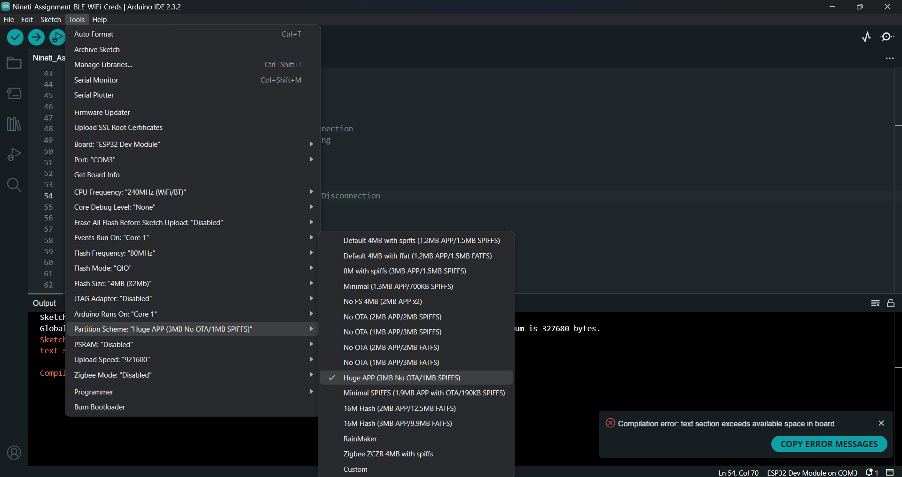

**Approach 2:**

* **Changed the board type to ESP32 Dev Module and switched the "Partition Scheme" setting in tools to "Huge APP (3MB No OTA/1MB SPIFFS)".**
* **Result: This resolved the compilation error and uploaded properly onto the board successfully.**
* **Comment: There is a lot of space available in the board memory, but it has different default partitions preset which can be changed as per use case.**

**Outputs**

**Serial Monitor Messages**

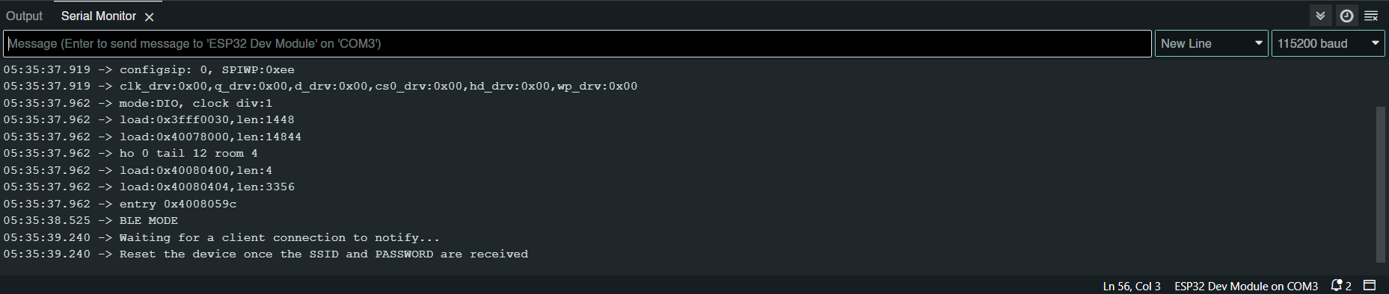

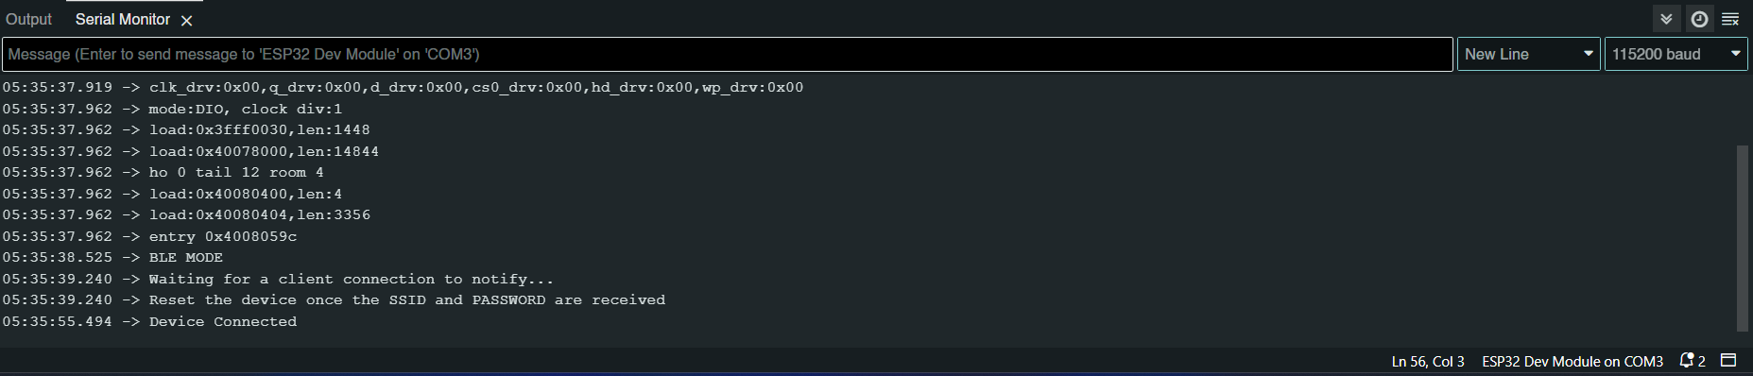

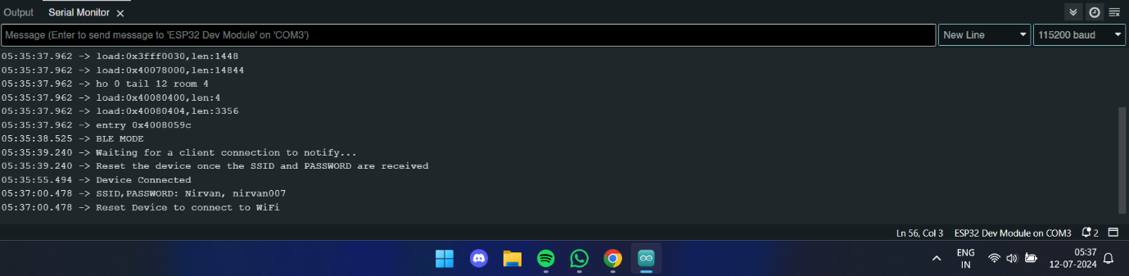

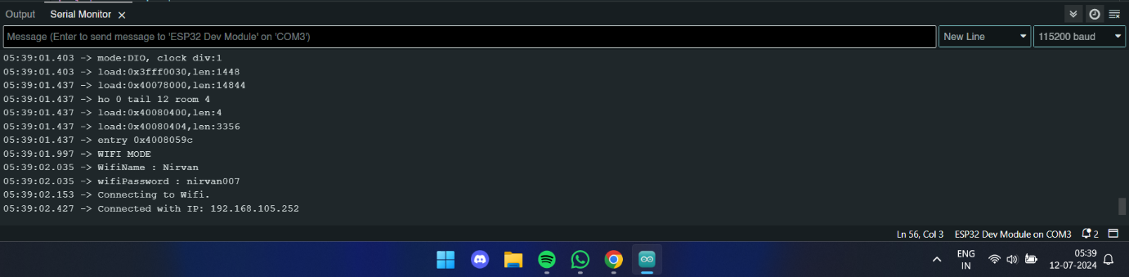

**nRF Connect Application interface**

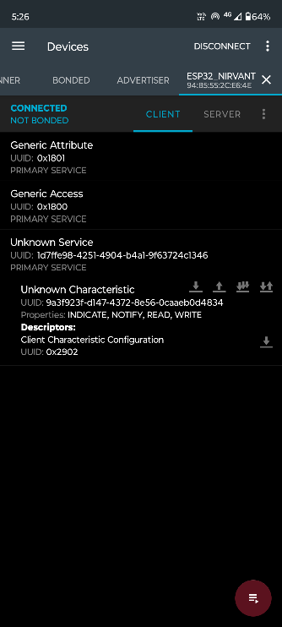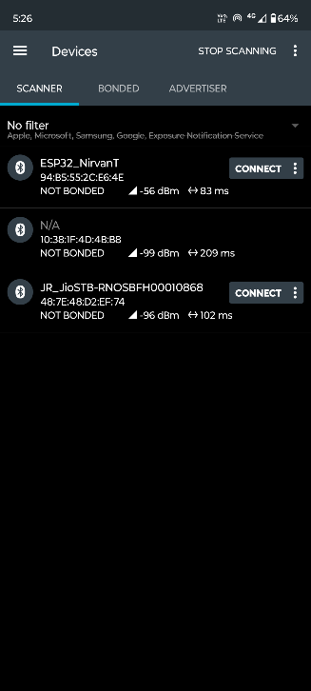

**Opening the User-Created Unknown Service**

**Connecting to the ESP32 Board**

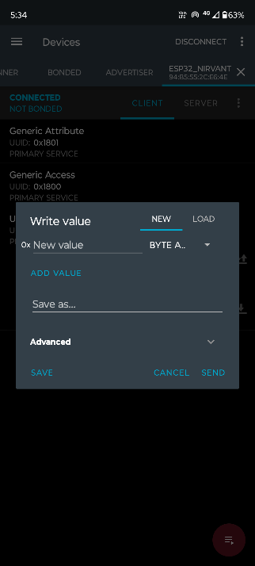

**Writing to the Board by Using the "Upward Arrow" in the Characteristic which Denotes the "Write" Command**

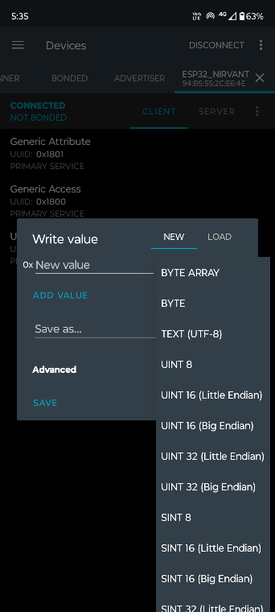

**Setting the "Write Value" to "TEXT(UTF-8)" to Send a String Value to the Board**

**Typing the Wi-Fi SSID and Password in the Format: "SSID,PASS" and Clicking Send**

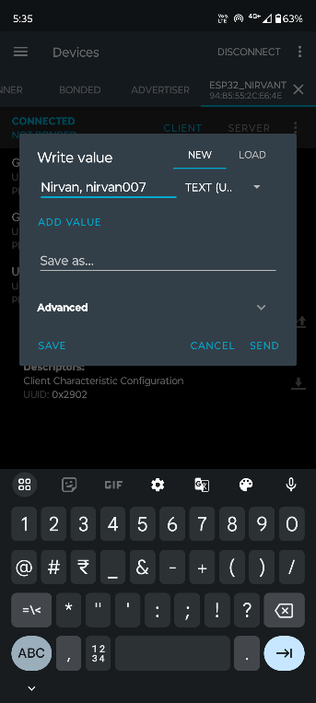

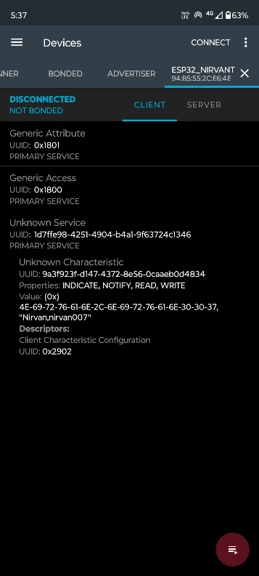

**Value is Being Written to the board**

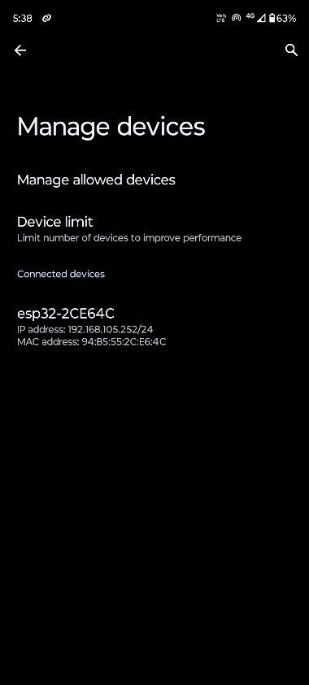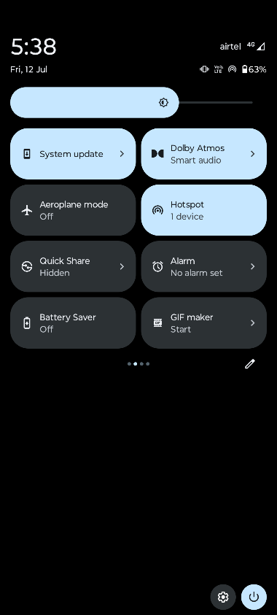

**The Device Receives the SSID and Password, then it has to be Reset so that it can Turn OFF the BLE and Connect to the Provided Wi-Fi SSID**

**References**

1. [**Random Nerd Tutorials: ESP32 Wi-Fi Provisioning BLE Arduino**](https://randomnerdtutorials.com/esp32-wi-fi-provisioning-ble-arduino/#:~:text=You%20connect%20to%20the%20ESP32,Fi%2Drelated%20tasks%20it%20needs)
2. [**iOS Bluetooth ESP32 WiFi**](https://github.com/mironal/iOS-Bluetooth-ESP32-WiFi/blob/master/Arduino/BLE_WiFi_ESP32.ino)
3. [**EspBlufiForAndroid Releases**](https://github.com/EspressifApp/EspBlufiForAndroid/releases)
4. [**ThatProject: Esp32_wifi_ssid_pw_via_ble**](https://github.com/0015/ThatProject/tree/master/Esp32_wifi_ssid_pw_via_ble/Esp32_WIFI_BLE)
5. [**Arduino Stack Exchange: Text Section Exceeds Available Space in Board**](https://arduino.stackexchange.com/questions/90925/text-section-exceeds-available-space-in-board)
6. [**ESP32 Forum: View Topic**](https://esp32.com/viewtopic.php?t=5292)

**…**